Clear Springs Tabernacle
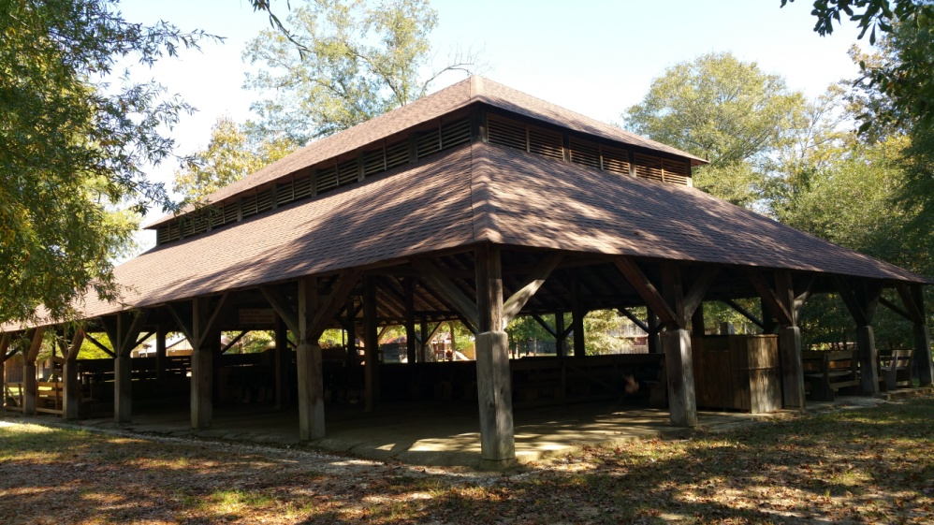
Clear Springs Tabernacle was constructed in June of 1887 by the board of trustees established in the Methodist Church of Clear Springs, Arkansas. The site was selected based on its rich history with the church. The church had been holding meetings on this site since 1872 under the leadership of M.E. Kelley and other ministers. Fifteen years later, Miles Kelly was appointed the task of building a new tabernacle. Many members of the church community stepped up to help with construction; one member even volunteered his lumber mill to help with the supplies for the tabernacle. Three months later the tabernacle was finished and the church held its first official meeting. The revival lasted for ten days and people gathered from all around to stay on the site in tents and cabins with their families and livestock. They worshiped together and fellowshipped for the ten days and then returned annually on the last week of July. Clear Springs Tabernacle was officially added to the National Register of Historic Places on February 13, 1992.
Today the Davidson Campground continues the camp meeting tradition and the church meetings are held there each year. This year marks the 131st meeting. Members still stay in the surrounding cabins that now number near one hundred. The property still has eight fresh water springs that the meeting uses for baptism, drinking, and bathing. Davidson Campground continues to serve the community and provide an outline for fellowship and growth.
Sources:
Batson, Blake. "History." Davidson Methodist Campground. 19 Aug. 2009. Web. 28 Oct. 2014.
Baughn, James. "Clear Springs Tabernacle." LandmarkHunter.com: Historic and Notable Landmarks of the United States. Web. 28 Oct. 2014.
Christ, Mark. "Arkansas Properties on the National Register of Historic Places: Clear Springs Tabernacle, Clear Springs, Clark County." Saving Arkansas Places. ARKANSAS HISTORIC PRESERVATION PROGRAM, 6 Aug. 2014. Web. 28 Oct. 2014.

