{1} Good Afternoon
My name is Kaitlyn Bolton, and I am a senior Business Administration major with an emphasis in Marketing, Management, and Sports Management and today I am going to be sharing with you my presentation…
“Empty Seats and Shallow Pockets: The Pandemic’s Effect on Stadiums and Arenas.”
I want to thank everyone for being here today and supporting me in this endeavor that seems to keep on going due to the continuation of research and data and the path that it could potentially put me on for my future.
Before I get started there are a few people that I need to thank.
First, I would like to thank, Dr. Faught who is my faculty sponsor and without his Big Data class last Fall, this project would not exist.
Next, my friends who have heard me talk about this project since fall semester and for trying to calm me down and encourage me when I became panicked and stressed.
And lastly, my parents who supported me in adding this to my already busy schedule and the rest of my family who are here supporting me today.

{2} While my research looks at some of the financial impacts that COVID-19 has had on our nation, I would like to take a minute to remember those who have lost their lives and the lives of family members and friends to this horrible disease. [count to 5 and then continue] COVID-19 has touched us all in many ways and my research is just one small part that has been impacted.

{3} Before we dive in head first, let me give you a little background on this project. Like I mentioned before this started as a class project for Big Data Mining with Dr. Faught. When the idea first popped up in my head, I wanted to look at all sports and all venue types. Due to the time constraint caused by a due date at the end of the semester, I had to decide on one sport and focus my project around it. I talked to venues with “home teams” and those that are sites for concerts and big non-sporting events. I made a survey and sent it to everyone I know and had family send it to everyone they knew, to get people’s opinions on safety restrictions at the time and if they felt safe attending an event. For the final project, I took into account the survey responses and looked at 3 different components, the team statistics by season, attendance numbers and numbers of games, and the revenue – all over the last 20 years.
Now let’s play a little game
Let’s see if you can spot the difference in these two photos
{4} [Photo #1] This is the stadium in San Francisco, California. Home to the San Francisco Giants.
{5} [Photo #2] This is the stadium in Washington D.C. Home to the Washington Nationals.
So obviously there is something missing in the 2nd photo. The first photo of the Giants Stadium is from the 2019 season and the second is a game from the 2020 season.
These pictures may have also told you what sport I picked to focus my project on. And some may ask why baseball?
{6} Well, the original project was due the first few weeks of December and at the time basketball was just getting started, football was nearing the end on season but was preparing for post-season play, and baseball was finished in late October. Plus, I just love baseball.
Major League Baseball was the first to figure out how to have some sort of season during COVID. We saw the “bubble” introduced where they keep all the player and coaches staying in one hotel or even turning the stadium into a big hotel. We have seen this concept of the “bubble” used in other sports and most recently in the NCAA March madness tournament. We have now seen the MLB start a second season post-COVID and there are a lot of restrictions in order to have fans and keep everyone safe.
So, with so much information to look at we are going to focus on three main points: {7}
- Revenue Loss
- Revenue Compensation
- 2021 Season

First, Let’s look at some numbers
{8} Prior to every season the MLB sits down and totals up the amount of expenses that would be required for the season. These expenses are complied of player and coaches’ salaries and then any other costs and fees that they have for running an organization, normally dealing with fans. The expected expenses for the 2020 season, before COVID, were totaled at $10.2 billion dollars. However, with COVID the expenses were only $6.1 billion dollars because there were so many employee layoffs and pay cuts and the other expenses that are needed due to providing everything for the fans, were not needed. With the expectation of a normal season, they were looking at bringing in $10 billion dollars in revenue. The total amount of revenue that a shortened COVID season brought in was $3 billion dollars. What is normally a $2 million dollar loss turned into a $3.1 billion dollar loss.
Now we have to look at the ways that teams and organization used to try and make up for some of this revenue loss.

The first thing that someone would think of is price increases.
{10} When conducting my surveys, one of the questions was “do you expect ticket and concession prices to rise in the coming season(s)?” the answers varied all over from yes-no-maybe and I followed up with the question of “would you be willing to pay these price increases?
I was on the side of thinking that yes, we are going to see ticket prices increase at least for this season if not for seasons to come and I was going to be willing to pay if it meant being able to go to the ballpark and have life feel somewhat normal again. However, I was getting ready for Opening Baseball Weekend at the University of Arkansas this is when I realized that the revenue loss for everyone is certainly different. If you bought a ticket through the school’s ticket booth, you would pay $15 for a regular ticket. This is a little higher than normal, but not a huge jump that was expected. Then, I looked on second hand ticket websites such as seat geek and Ticketmaster and the same tickets were $150. Those websites are normally a place to fins cheaper tickets, in this case not so much.
The average cost for a ticket has gradually gone up over the last few years in the MLB. The average ticket in 2019 was $32.99. In 2020 it was expected to be $34.04. Of course, opening day tickets are going to be more expensive but for the Dodgers they had a $160 dollar jump from 2019 to 2021. This is the case for lots of teams around the nation and not only in the MLB, other sports and activities are sure to see a spike as well.

{11} Other ways that we have seen teams try to compensate for the revenue loss are the use of Cardboard Cutouts. Some teams and fans, like the guy in this photo, had a lot of fun with this. The prices range from team and depending on where the cutout would be in the stands. The cheapest that I found was $25 for season ticket holders of the team. The most expensive was $500 and had a prime place in the stadium. It was only select teams, not everyone participated. There were select fans and select seats. Some teams had restrictions on how many they were selling. They also had restrictions on what could be in the photo. Some could be selfies, others had to be a photo taken of you. Only one person per photo, unless you were holding a baby, but no group shots and each team was picky. For some of the teams you could pay more to be seated by celebrities that also had a cutout. The Arizona Diamondbacks had healthcare workers, free of charge, in their stands. Some teams had a section of just pets. For the Seattle Mariners, if your cutout “caught” a foul ball or a home run, they would package it up and send it to you. The funds from the sales of the cutouts would go to support team organizations or charities of the team’s choice.
{12} A few other ways that we saw teams try to make up for revenue loss were opening their parks for batting practice or catch in the outfield. The minor league team in Northwest Arkansas did this pretty consistently during the summer. You paid a small fee for however much time and got to feel like you were playing in the minor leagues. Other places put on other events such as cornhole and disc golf tournaments. We saw places turned into drive-in movie style where you could bring your family and a blanket and camp out in the outfield and watch a movie on the big screen. Then during the holidays there were themed events like trick or treating or Christmas light displays. All events that charged admission and encouraged fun socially distanced activities. The empty stadiums and arena were also used for blood drives, voting sites, and COVID testing and vaccine distribution, but did not necessarily receive revenue from these events.
Now let’s take a look at what all is in place to have a safe season with fans in the stands.
{13} The MLB is leaving most of the COVID restriction decisions up to the teams. This is because every team is a in a different city that is seeing different numbers in cases, and each city had different restrictions. Other regulations that the MLB is in charge of are being delt with the most precaution. The team in North little rock is looking to hire a Clubhouse Manager, whoever is hired for this position is only allowed in the clubhouse, not allowed in the concourse, and is not allowed to dine indoors basically quarantine for the summer. Most teams are expecting some minor changes throughout the season, but they are not guaranteed.
All the stadiums, but one, have decided to have a limited capacity. The Texas Rangers are the only team in the league that is open full capacity. Opening day looked like this.
[Video]
The tickets are super cheap, but they are also in a brand-new stadium and probably have a little more revenue loss to make up for.
Other stadiums range from 12% to 50%
Most stadiums are requiring a mask unless actively eating or drinking, but I expect this to change with the distribution of the vaccine and changes in regulations. However, the New York Yankees and Mets are requiring a negative PCR Covid test within 72 hours of game time to be admitted.
Let’s compare some other teams and how numbers look different all over the league.
{14} Chart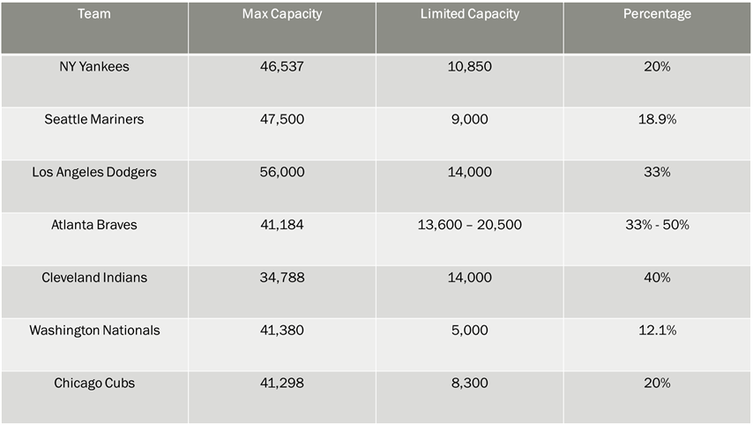
Now the question you’ve probably had since the beginning, “What else can she research and how else can she extend this project?”
{15} Well I have that answer for you.
I have talked about looking into colleges and universities and how it affected them, and also the different divisions some that had sports and some that did not. Like OBU didn’t have football but has had most the other sports.
Looking into the other pro sports and having a branch dedicated to just concert venues and arena type places.
With the distribution of COVID vaccines, it is making things a little easier and organizations are relaxing restrictions which would provide much more research for a continuation.
{16} I would like to close by saying Thank you again to everyone here and supporting me in many different ways. At first, I thought I was crazy for adding this on to my plate but realized the type of influence it could have on my education and future career. I would like to now open the floor for any questions that you may have.

